When planned future route includes roads currently closed (I am assuming here), The pop warning below presents. I click on Help me solve this problem – and the message on the next screen snippet is presented.
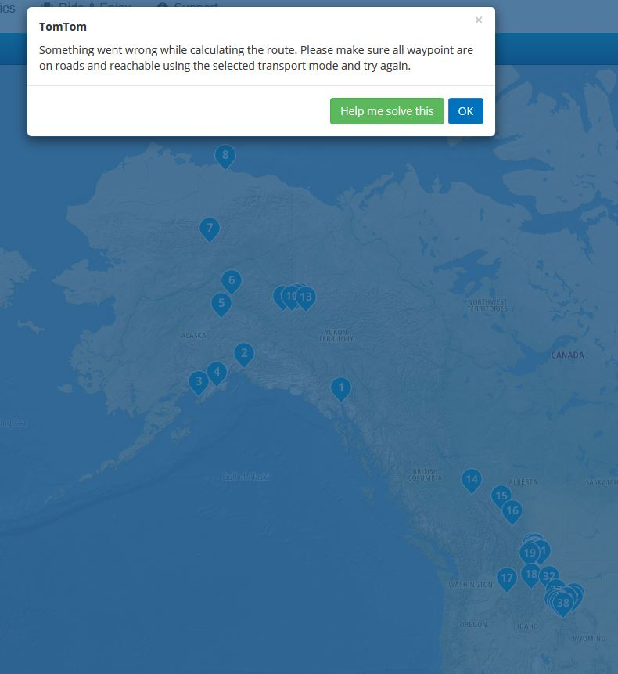

I am presented with a message that details waypoints that have road closed between them. The third screen snippet shows the route gap….
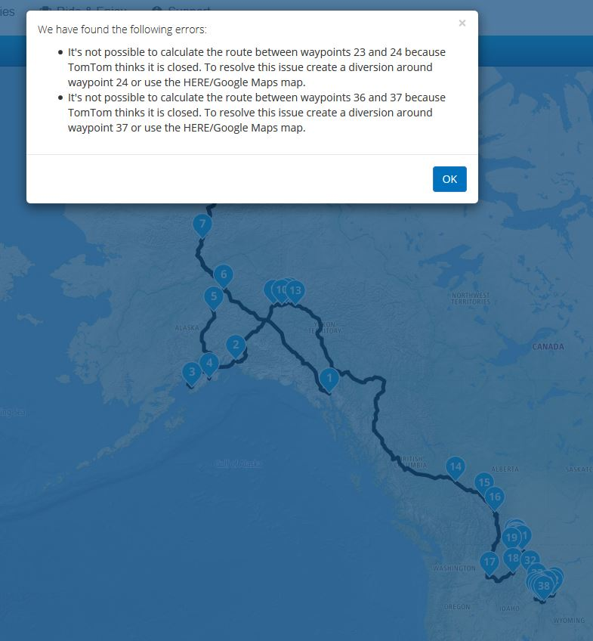

The route gap – sometimes the routing takes me clear around the closed road, even when I know the road will be open in the summer (absent some other reason to close roads – like future wildfires or rock slides, etc.).
